Hello, Mayors! I’m Guillaume Pierre, the lead gameplay scripter on *SimCity*, and today I’m presenting the raise/lower road tool. This tool allows for the easy creation of bridges and tunnels, along with trench roads and roads on retaining walls.

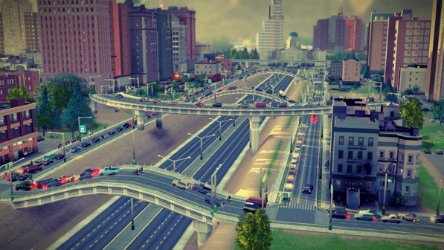

Let me explain how it works. When drawing a road using the straight, arced or curvy tools, you can press the M key to raise the segment by 6 meters per key stroke. Note that the end points of the road segment do not go up, but stay at their respective original ground positions.

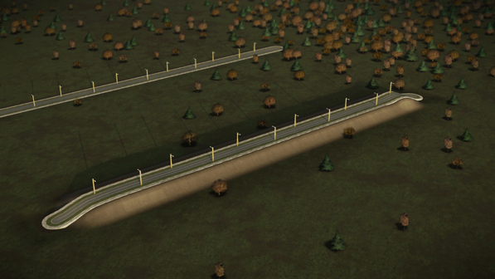

For the first two key strokes, the road will be on top of a retaining wall, and the terrain may rise to meet it if there is no structure nearby. Starting on the third key stroke, a bridge will start forming. Sometimes you may have to bring the bridge to a fairly high elevation so it can go over other roads, but doing so will allow you to control your traffic more effectively.

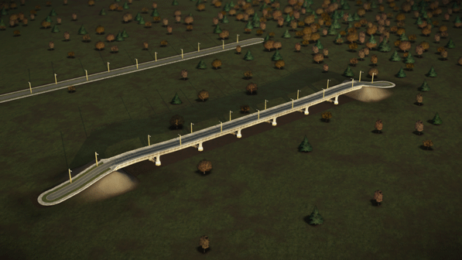

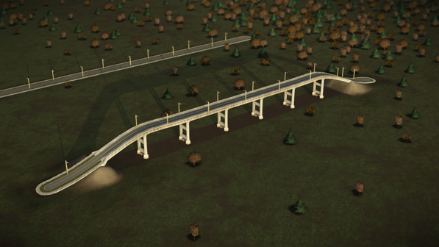

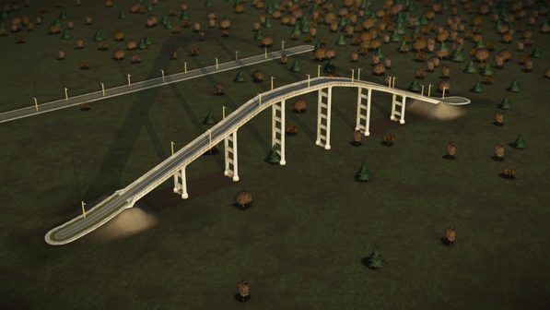

You can also press the N key while drawing roads, which will have the opposite effect and lower the segment. The first couple key strokes dig a trench for the road to lie in, while additional key strokes will create a tunnel if there is sufficient room and ground. Like bridges, tunnels are also an effective way to deal with traffic, especially in areas that have a lot of mountainous terrain, like the [**recently released Granite Lake region**](http://www.simcity.com/en_US/blog/article/building-granite-lake).

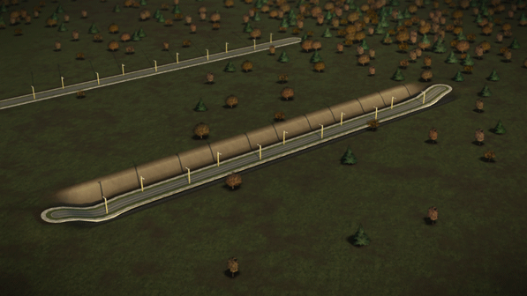

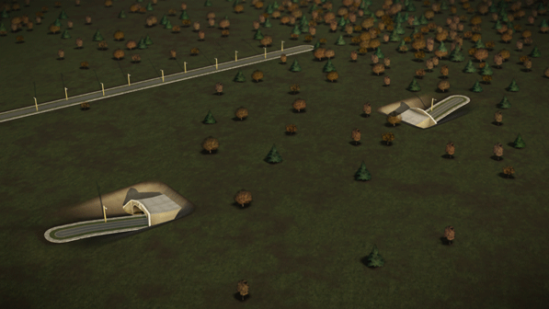

Finally, you can stack multiple tunnels and bridges on top of each other, as long as you have enough vertical clearance between each road.

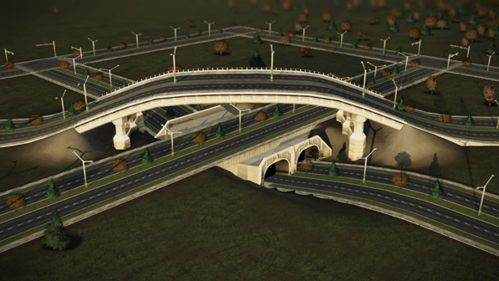

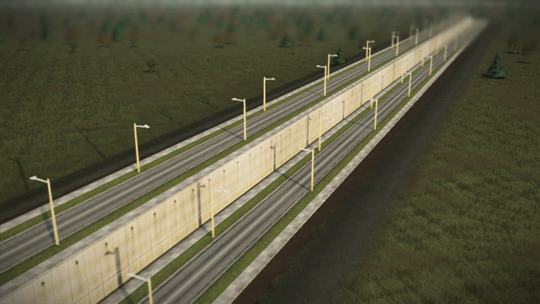

As you can see, the raise/lower tool is going to not only offer a new level of creativity when building your cities, but also give you more control over you handle your traffic. Want to see more screens?